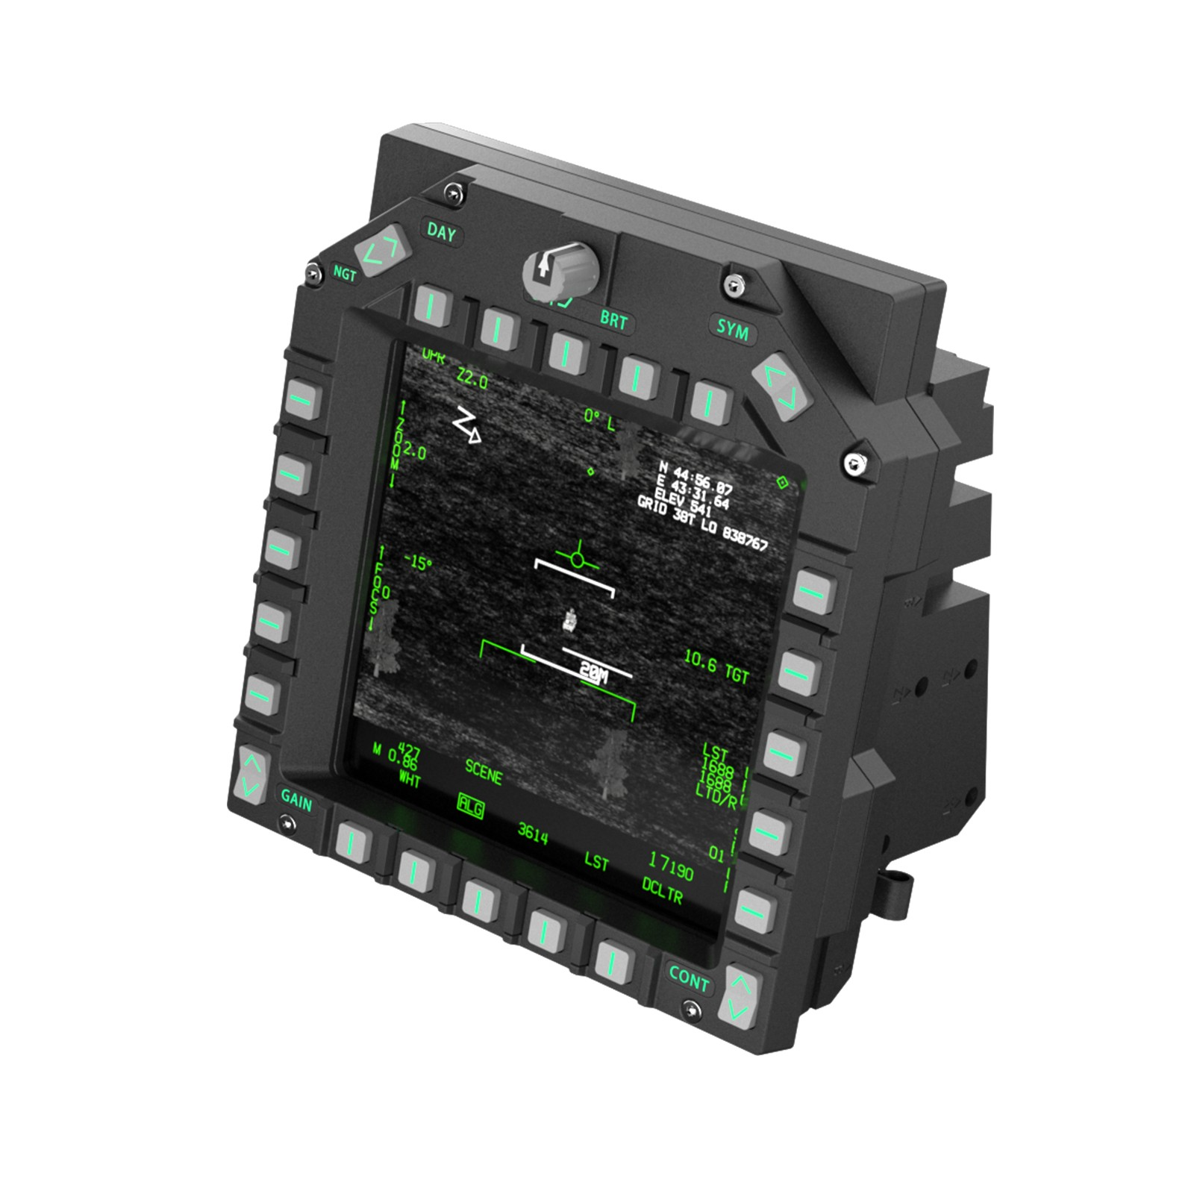
104 - Controls - DDIs
U=Up, D=Down, N=Neutral, F=Forward, B=Backward, L=Left, R=Right, P=Press, S-*=Shift-*, L-*=Long-*

Left DDI: Comms
Side Switch: --
Day/Ngt: -- BRT Knob: -- Push: Clock Start/stop SYM: --

[ H ] | | [ 1 ] | | [ 2 ] | | [ 3 ] | | [ - ]
[ ] | | [ ] | | [ ] | | [ ] | | [ ]
[ A/G ] [ 5 ]
| | | |
[ B ] [ 6 ]
| | | |
[ C/F ] [ 7 ]
| | | |
[ C2 ] [ 8 ]
| | | |
[ D/E ] [ 9 ]
[ 0 ] | | [ 1 ] | | [ 2 ] | | [ 3 ] | | [ 4 ]
[ ] | | [ ] | | [ ] | | [ ] | | [ ]

GAIN: -- CONT: --

Right DDI: Radar, Weapons, Countermeasures
Side Switch: Radar Mode (a0,a1,a2)
Day/Ngt: Radar Brightness BRT Knob: Radar Gain Push: -- SYM: RDR Night Filter

[ ] | | [ ] | | [ ] | | [ ] | | [ ]
[ ] | | [ ] | | [ ] | | [ ] | | [ ]
[ ] [ ]
| | | |
[ ] [ RDR Lin/Log ]
| | | |
[ ] [ Passive Mode ]
| | | |
[ ] [ RDR MEM Mode ]
| | | |
[ ] [ RDR TA Mode ]
[ CM ] | Jam | [ CM ] | Jam | [ ] | | [ ] | | [ ]
[Mode ] | Mode| [ Mode] |Band | [ ] | | [ ] | | [ ]

GAIN: Weapon Mode Selector CONT: Weapon Interval

Center DDI: Displays, Nav, CK-37
Side Switch: --
Day/Ngt: Data Cart Sel BRT Knob: -- Push: Insert Data Cart SYM: KB Page

[ B6 ] | F1 | [ B7 ] | F2 | [ B8 ] | F6 | [ B9 ] | F10 | [ BX ]
[ ] | Ckpt| [ ] |Exter| [ ] | Wpn | [ ] | map | [ ]
[ B5 ] [ ]
|Restart Mission| | Rearm |
[ B4 ] [ ]
| | | |
[ B3 ] [ ]
| Time Norm | | Briefing |
[ B2 ] [ ]
| Time Accel | | Reslot |
[ B1 ] [ ]
[ ] | Info| [ ] |Show | [ ] |Pause| [L MAL] |Activ| [ LS ]
[ ] | Bar | [ ] |Ctrls| [ ] | | [ ] |Pause| [SKU ]

GAIN: EP-13 Brightness CONT: EP-13 Contrast

inspiration for non-mfd planes:

